Purpose Learning Lab, Inc Presents…..CAMP PURPOSE 2021….”Where S.T.E.M., Innovation, & Adventure Awaits
Sample Schedule
Weekday | 8:00-9:30 | 9:30-10:00 | 9:30-12:00 | 12:00-12:30 | 12:30-1:30 | 1:30-3:00 | 3:00pm | 3:30-5:00pm
Monday  AM/PM/T  DIY Inventions  8:30-9:30am  ZP | AM Arrival  Table Toy Extravaganza  Journal Expression by Zamiah  IXL/Moby Max | AM Snack  Family  Style  Dinning  Math Facts | Zione’s Rocking Robotics & Coding  9:30-10:30  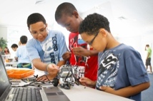  DIY Inventions! | Lunch  Picnic  Style Dining | Skating (A) week  11am-2pm  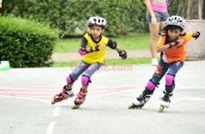  Swim (B) Week 1pm | Dre’s Workout Stadium    2:30-4:00pm (M) | PM Snack  Family  Style  Dinning  Math Facts | PM Mini Workshops (Timed Stations)  Group Activity Zone  Outdoor Exploration  Electronic Palooza  (Wii, PS3, IPad, CPU)
Tuesday  NO/T  Slime 1:30-2:30pm | AM Arrival  Table Toy Extravaganza  Journal Expression by Zamiah  IXL/Moby Max | AM Snack  Family  Style  Dinning  Math Facts | Mikhail’s Stinging S.T.E.M Challenges   | Lunch  Picnic  Style Dining | Kayla’s Picasso Paintings  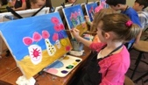  Ziah’s Slime Exhibit  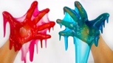 | Zay’s Open Gym/Clinics  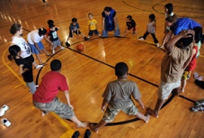 | PM Snack  Family  Style  Dinning  Math Facts | PM Mini Workshops (Timed Stations)  Group Activity Zone  Outdoor Exploration  Electronic Palooza  (Wii, PS3, IPad, CPU)
Wednesday  AD/T | AM Arrival  Table Toy Extravaganza  Journal Expression by Zamiah  IXL/Moby Max | AM Snack  Family  Style  Dinning  Math Facts | Indoor Swim  Inflatable Fun   | Lunch  Picnic  Style Dining | Movie Projection Screen   | Dre’s Sport Stadium | PM Snack  Family  Style  Dinning  Math Facts | PM Mini Workshops (Timed Stations)  Group Activity Zone  Outdoor Exploration  Electronic Palooza  (Wii, PS3, IPad, CPU
Thursday  NO/T  Y.E.S. Seminar 1:30pm-2:30pm | AM Arrival  Table Toy Extravaganza  Journal Expression by Zamiah  IXL/Moby Max | AM Snack  Family  Style  Dinning  Math Facts | Dally J & Aniyah’s Kitchen Chemistry    Amyiah’s DIY Inventions! | Lunch  Picnic  Style Dining | Youth Empowerment  Seminar  Presented by Ms. Mya   | Zay’s Open Gym/Clinics | PM Snack  Family  Style  Dinning  Math Facts | PM Mini Workshops (Timed Stations)  Group Activity Zone  Outdoor Exploration  Electronic Palooza  (Wii, PS3, IPad, CPU)
Friday  AD/T | AM Arrival  Power in my Pen!! Journal Expression by Zamiah & Emmy | AM Snack  &  Math Facts | Field Trip    Water Play/Park | Lunch  Picnic  Style Dining | Field Trip  Water Play/Park | Gaming Zone   | PM Snack  Family  Style  Dinning | Freedom Friday!!!  Group Games  Mini Workshops  Extended Electronic Palooza

